Your Region of Opportunity
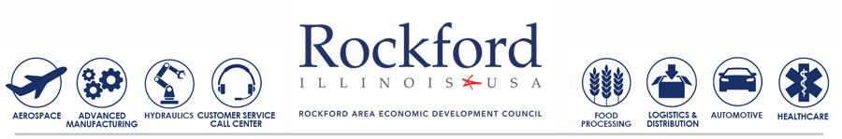

PRESIDENT’S NEWSLETTER
| August 2016 |

My Perspective – Letter to the Rockford Region

A Redeveloped Website
One of the more important marketing tools which the RAEDC uses in attracting new businesses to our region is RockfordIL.com. The RAEDC website is the first impression many site selectors, real estate brokers and business owners have of our Region.
READ MORE >>>
The RAEDC and the Rockford Region
The RAEDC, as the Economic Development Agency for the region is also the data collection agency on all new capital investment in the area, retained and created jobs, and new or renovated space. As we enter into our Rockforward20/20 strategic plan, we will be informing all of you on project wins for our region as well as projects that we are working on with our various regional partners.
Measurements
These figures represent the collective successes during the new Rockforward20/20 strategic plan. The plan began in January 2016 and will continue through December 2020.

The results shown below are for the first 8 months of the 60 month Rockfordward20/20 strategic plan.
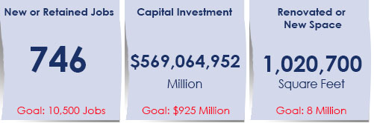
Three projects closed in August including the attraction of a company in the logistics cluster, the regional retention of an information technology company, and the expansion of a company in the tourism sector.
RAEDC Updates
Results of Workforce Study Released
The workforce development project, funded by the JP Morgan Chase Foundation Grant, focused on regional skills gap analysis and collaboration towards the utilization and sustainability of a "collective impact" workforce development model pertaining to a common agenda and consistent messaging to constituents.
PROJECT REPORT>>>

The Economic Health of the Rockford Region is Strong
Article by Mike Nicholas
Currently more than $1.5 billion is being invested in the region. The area's healthcare providers are generating more than 50% of that investment. These investments will benefit the region in many ways.
READ MORE>>>

Regional Wins
RDF SIgns New Air Cargo Tenant
With the new tenant at the Chicago Rockford International Airport cargo flights from ABX Air will start Sept 9th. They will begin once daily and over the course of the next six months increase to five or six times daily.
READ MORE>>>
Rockford Makes National List of Fastest Growing Housing Market
USA Today recently announced Rockford, IL has the 6th fastest growing housing market in the USA.
READ MORE>>>

Comcast to Deliver Gigabit Internet Service Over its Existing Infrastructure
Comcast launched the Chicago area trial of a new Internet service today that delivers speeds up to 1 Gigabit-per second (Gbps) to customers. The service will use DOCSIS 3.1 technology to deliver these speeds over the company's existing network infrastructure.
READ MORE>>>

Regional Good News
Community Survey - Please take a moment to provide your feedback
Transform Rockford's Living the Brand Spoke Team and partners, are launching a community wide survey in regards to the Rockford region's image. Deadline for completion is Friday September 16.
COMPLETE SURVEY>>>
NIU EIGERlab FastPitch Competition Deadline Approaching
Local innovators and entrepreneurs are invited to share their products, service or "ideas on a napkin" for a chance to win $5,000. This year's FastPitch Competition will be held Wed, Sept. 28, at NIU-Rockford. The deadline for FastPitch participants to submit their business pitches in writing for pre-qualification is Thur, Sept. 15.
READ MORE>>>

AmeriCorp Ranks Rockford in Top 10 List for Providing Volunteers
AmeriCorp ranks Rockford number 6 for its volunteer enrollment. AmeriCorp is a portal to match volunteers with non-profits to better the community and volunteers work with Youth Build Rockford to build and renovate affordable housing.
READ MORE>>>

Visitor Spending Sets New Record in Winnebago County
An Update from Rockford Area Convention & Visitors Bureau
Rockford and Winnebago County continues to see an increase in tourism spending expenditures - the total amount of money travelers spent during their time in the region - reached $349.91 million in 2015, a 3 percent increase over the prior year's record setting numbers.
READ MORE>>>

Rockford Chamber of Commerce Releases Relocation Guide
The Chamber of Commerce has released the 2016 edition of their Relocation Guide. Copies are available at the Chamber of Commerce Offices, throughout the Rockford Region or online.
READ ONLINE>>>

RAEDC Events
Annual Meeting & Dinner: Wednesday, November 16th

The Annual Meeting and Dinner has been confirmed for Wednesday, November 16th at Giovanni's Restaurant & Conference Center. The RAEDC Board of Directors and Staff are proud to welcome Mr. David Storch, Chairman, President and Chief Executive Officer of AAR, as the keynote speaker.

AAR is a leading provider of diverse products and value-added services to the worldwide aviation/aerospace and government/defense industries.
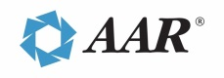
Table and ticket sales will begin on Thursday, September 15th.

For more information contact Jimsi Kuborn, Vice President of Investor Relations at 815-969-4259 orJKuborn@RockfordIL.com.

Principal Sponsor | Keynote Presenting Sponsor

Premier Sponsors
Baker Tilly, First Northern Credit Union, Greenlee, Mercyhealth, Meridian, Nicor Gas,
PCI Pharma Services, Inc., SwedishAmerican, Venture One, Woodward

Rockforward20/20
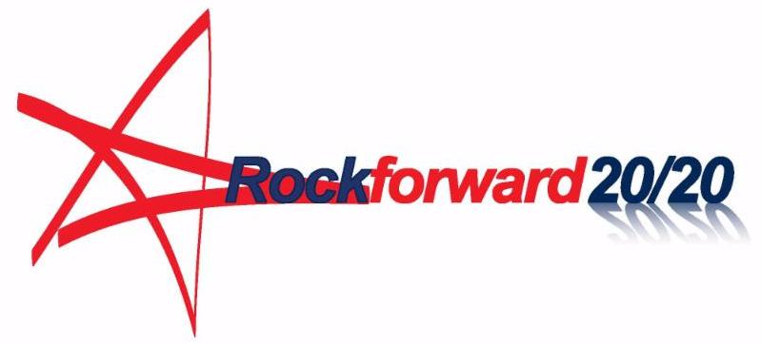
Rockforward20/20 represents a bold vision for our future, this aggressive plan will cultivate opportunities to create and retain over 10,000 jobs and significantly increase capital investment in the region.
Learn more at RockfordIL.com/Rockforward2020. If you have not set up a brief meeting to explore how you can get involved, contact Jimsi Kuborn at 815-969-4259 or jkuborn@rockfordil.com.

The RAEDC
The RAEDC often works behind the scenes due to the confidential nature of business projects. Plus, big deals take time: The average time from start to completion on the 24 project wins in 2015 was 329 days.
We are committed to persistence and continuity in our work: We market the Rockford Region to the world, influencing companies to locate or expand here. We support and promote growth within targeted industries through regional public-private collaboration. We assist prospective and existing companies by connecting them to resources for workforce development, available buildings, supply chain partners, incentives and more.
Together, we will continue the momentum into 2016 for an even stronger, more sustainable economy. Together, we will Trailblaze, Inspire Action, Align, Seed and Serve!
Michael Nicholas, President
MNicholas@RockfordIL.com
ABOUT THE RAEDC
The primary role of the Rockford Area Economic Development Council (RAEDC) is to collaboratively improve the economic strength of the Rockford Region by helping employers retain and create quality jobs. The RAEDC works closely with many partners to learn what existing and new employers need to grow, and to serve as a one-stop resource for clients. The RAEDC seeks to improve the competitiveness of the region by taking what it learns from the region's employers, and engaging the community in the daily work of economic development.

Rockford Area Economic Development Council
100 Park Avenue, Suite 100, Rockford, IL 61101 | information@rockfordil.com
T: 815.987.8118 | www.RockfordIL.com

